CURRICULUM VITAE
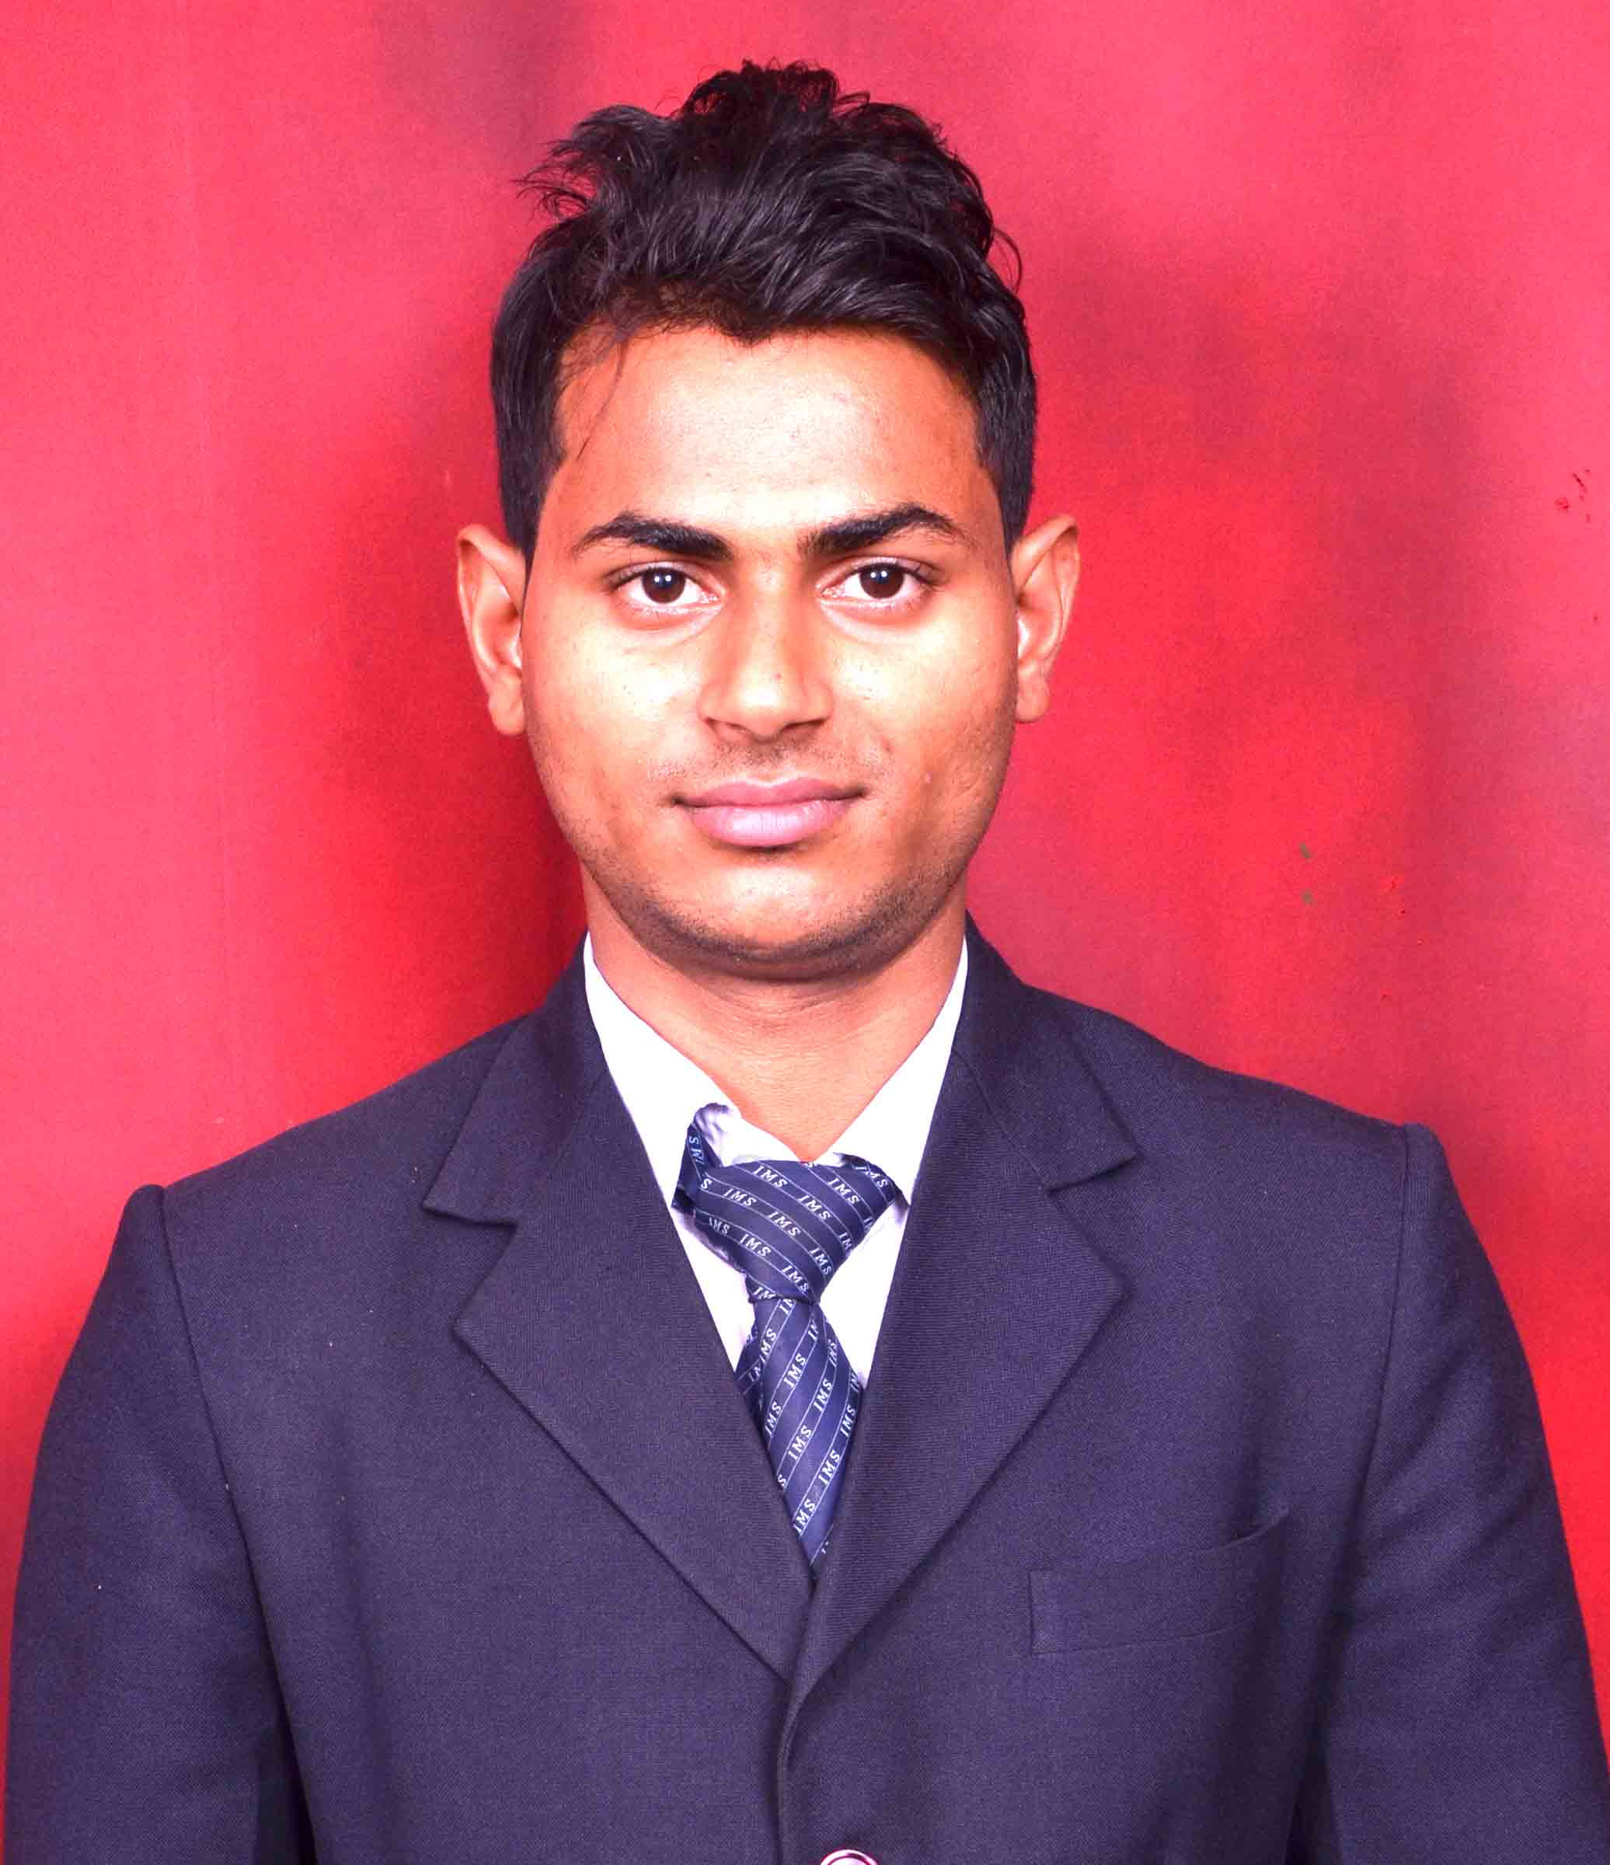

MOHD. ZAHID
Mechanical Engineering,
IMS Engineering College, Ghaziabad
CONTACT NO: +91-8800910151, 7011876727
E-Mail: zahid.mohd786@gmail.com

CARRIER OBJECTIVE

To give my best in my professional pursuit for overall benefit and growth of the company that I serve by facing the challenges will show my caliber and gain some experience.

WORK EXPERIENCE

Company Name: INDUSREE POWER PVT LTD
Designation : DESIGN ENGINEER
Key Skill : AUTOCAD, SOLIDWORKS & 3D Printing
Duration : OCT 2016 to Till NOW

Job description
- 3D Printing prototypes for industrial professional.
- Making Swirl Turbine components using 3D printing.
- Experience complete manufacturing of impeller of Swirl Turbine by using 3D printer.
- Analyzed special applications and created manufacturing designs and Resolved engineering problems and developed 3D models using SOLIDWORKS
- Prepared and maintained technical drawings for industry review and Implemented revisions for all existing drawings using SOLIDWORKS.
- Assigned with the responsibilities of site survey and creating the Construction drawings, Contour Plan,3D model using AUTOCAD and Civil 3D for Hydro Power Projects.
- Responsible for complete creating and modifying Detailed Project Report of Hydro Power Project & Solar Power Project.

Company Name: UDYAMI SAHYOG PARISHAD
Designation : Engineer Design CAD/CAM & Trainings
Key Skill : SOLIDWORKS, AUTOCAD, CNC
Duration : OCT 2015 to APRIL 2016

Job description
- Provide trainings on SOLIDWORKS as CAD Professional And CAD Expert which is certified by DASSAULT SYSTEM
- Provide trainings on CNC and help to conduct assessments under PMKVY Scheme
- Provide trainings on AutoCad under ASDC and NIESBU

SOFTWARE SKILL

- Catia V5- Expertise Surface Modelling and BIW (Body in white)
- SolidWorks- Cad Professional and Cad Expert
- AutoCad- Expertise 2D and 3D
- CNC- Milling and Lathe
- 3D Printing- Making 3d Project
- Civil 3d- Making Contour Plan, X-section and L-Section
- Key Shot 5- Rending and animation

ACHIEVEMENTS

- I provided two week industrial training on CNC in R.D ENGINNERING COLLEGE
GHAZIABAD .
- I created some modify concept of Maruti Suzuki Shift and Alto 800 by using CATIA V5.

FINAL YEAR PROJECT

Project Title : Design and Fabrication of Solar Peltier Refrigerator
Software used for Designing : Catia V5

EDUCATION

B.Tech from IMS Engineering College Ghaziabad, approved by AICTE, New Delhi in Mechanical Engineering stream.
DEGREE/CERTIFICATE | UNIVERSITY/  BOARD | YEAR | PERCENTAGE
B.TECH | UPTU | 2011-15 | 67.06%
INTERMEDIATE | U.P BOARD | 2011 | 60.60%
HIGH SCHOOL | U.P BOARD | 2009 | 47.67%

PERSIONAL DETAILS

Father's Name : MOHD.IQBAL
Mother’s Name : PHUL MIJRA
DOB : 06-08-1993
Gender : MALE

Permanent Address : WARD NO 11 MURGIFARM
DASNA GHAZIABAD (201009)
State : UTTAR PRADESH

Place: GHAZIABAD (MOHD. ZAHID)

